December 10, 2020
Ref: IIH/MD/2020/12/010
His Excellency,
The Executive Governor of Kwara State,
Government House,
Ahmadu Bello Way,
GRA, Ilorin, Kwara State.
Your Excellency Sir,
RE: REQUEST TO SETUP ADVISORY GROUP FOR KWARA STATE
In response to your question commented on our initial letter with the above subject, my suggestion for a quarterly honorarium for members of this group is N250,000 (Two hundred and fifty thousand naira only).
Yours truly,
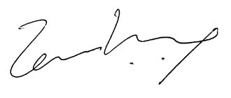

Temi Kolawole
MD Ilorin Innovation Hub

